Manual Data Collection & Upload Instructions:

SQL Server Logs
Please collect the log file written do during the timeframe of the incident and at least the next newest/oldest log files if available. (E.g. if the incident occurred during the timeframe of ERRORLOG.2, please collect at least ERRORLOG.1, ERRORLOG.2, and ERRORLOG.3).

- Identify the log directory. This can be done using one of several methods.
  - Configuration Manager
    - Open SQL Server Configuration Manager.
    - Go to the properties of the instance.
    - Go to the “Startup Parameters” tab (2012 and newer) or “Advanced” (2008 R2 and older)
    - Locate the startup parameter that starts with “-e”. This line contains the full path to the log directory.
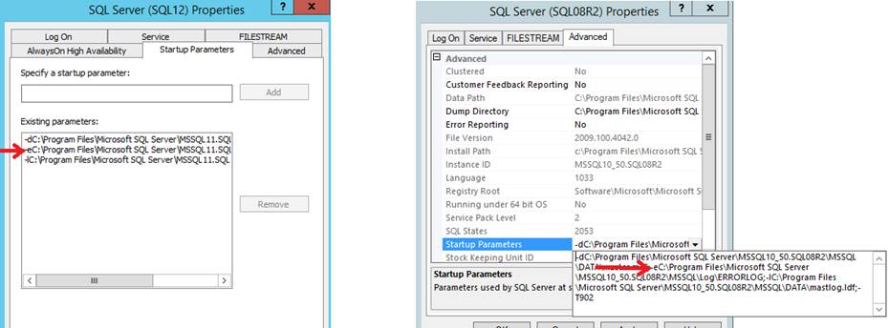
  - Reading the Errorlog from SQL Server Management Studio
    - Execute sp_readerrorlog from a query window in SSMS
    - Find the entry that reports the registry startup parameters
    - The error log directory is prefaced with “-e”
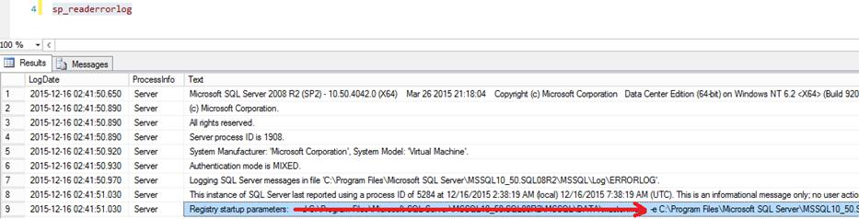

Windows Cluster Logs

Please generate and collect the cluster logs of all nodes in the cluster. This is probably easiest using PowerShell.

- Run PowerShell as administrator.
- Import-Module FailoverClusters
- Get-ClusterLog
- Get-ClusterNode | Where-Object {$_.State -eq "Up"} | ForEach-Object {explorer ("\\" + $_.Name + "\c$\windows\cluster\reports")}
- The cluster logs are aptly named “cluster.log”
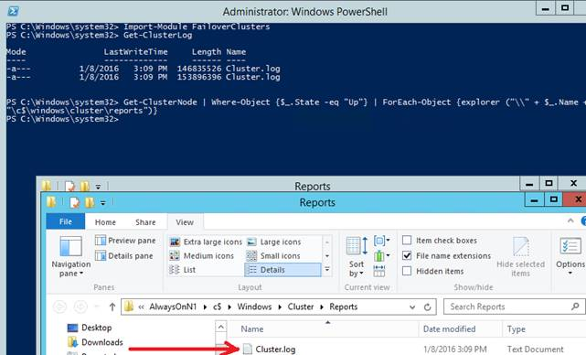

Windows Application & System Logs

Please export both the application and system log from the Event Viewer as a tab-delimited text file.

- Open the Event Viewer. This can be done using WIN+R (run), then typing eventvwr and clicking OK.
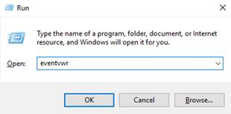
- Expand the Windows folder, and select the application log. Then click on “Save All Events As…”
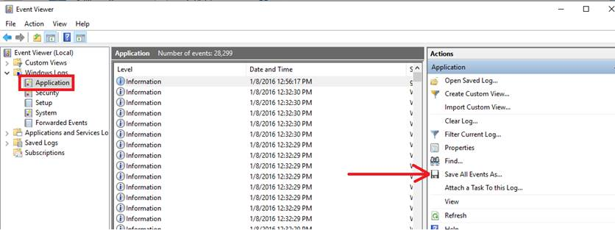
- In the “Save As” dialog, choose the Text (Tab delimited)(*.txt) option
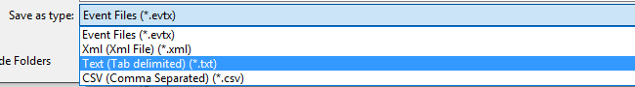
- Repeat steps 2 and 3 for the System log.

Compressing Files

There are many options for this as well. The easiest on any Windows 2008R2 and newer machine is the default Windows compression. Put all of the files in a common directory

- Put all of the requested files in a common directory.
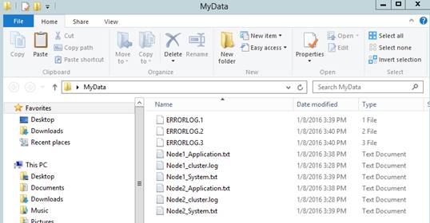
- Right-click on that directory→Send to→Compressed (zipped) Folder
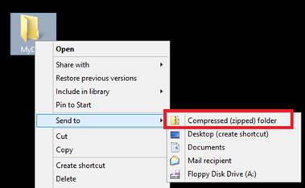

Uploading Data

After the requested data has been collected and put into a compressed folder (.zip/.rar/.7z/etc), then use the Data Transfer Management workspace to securely upload the data to Microsoft. Information to access the workspace should have been sent to you via email from CTS Automated Diagnostic Services. If you did not receive an email with a username and password, please contact me.

The workspace may be accessed using either a browser client accessible from https://filetransfer.support.microsoft.com/EFTClient/Account/Login.htm, or a small Windows application which may be downloaded from https://filetransfer.support.microsoft.com/EFTClient/Account/DTM.exe. These are just two different interfaces that serve the same purpose – either may be used.

